# **Assignment:**

**Module -1: Understanding of Hardware and Its Components**

Section 1: Multiple Choice

1.Which of the following is NOT a component of the CPU?

ANS: RAM

2.What is the function of RAM in a computer?

ANS: The function of ram is to store the data in your computer and lets you open apps and files quickly

3. Which of the following is a primary storage device?

ANS: HDD and SSD

4.What is the purpose of a GPU?

ANS: It handles the calculations relating to graphics, such as geometry, color, shading, and textures, and frees up the CPU for other tasks

Section 2: True or False

5. The motherboard is the main circuit board of a computer where other components are attached

Ans. True

6. : A UPS (Uninterruptible Power Supply) is a hardware device that provides emergency power to a load when the input power source fails.

Ans. False

7.An expansion card is a circuit board that enhances the

functionality of a component.

Ans. True

Section 3: Short Answer

8. Explain the difference between HDD and SSD.

Ans. DIFFERENCE BETWEEN HDD AND SSD

|  |  |  |  |  |  |  |  |  |  |  |  |  |
| --- | --- | --- | --- | --- | --- | --- | --- | --- | --- | --- | --- | --- |
| |  |  | | --- | --- | | **HDD** | **SSD** | | Full form Hard Disk Drive | Full form Solid State Drive | | HDD contains moving mechanical parts | SSD does not contains, mechanical part | | HDD is larger in size | SSD is more compact in size | | HDD is cheaper | SSD is costly | | HDD is heavier in weight | SSD is lighter in weight | |

9. Describe the function of BIOS in a computer system.

**Ans.** BIOS is a critical component of the computer system, as it provides a basic framework for hardware initialization and control. It is essential for the proper functioning of the computer and is often the first program that is executed when the system is powered on.

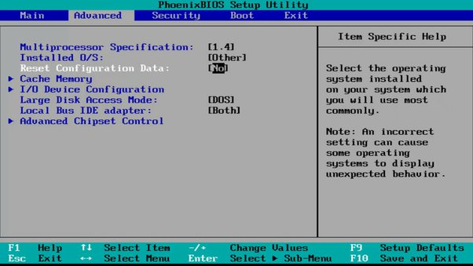

**<-Its look like this**

10. List and briefly explain three input devices commonly used with computers.

Ans.

1. **keyboard**:

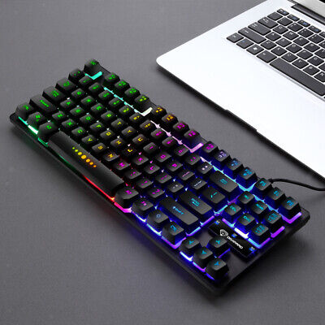

A keyboard is a device that allows users to enter text, numbers, and special characters into a computer. It consists of a set of keys that are arranged in a grid, and each key corresponds to a specific character or command.

**2.Mouse**

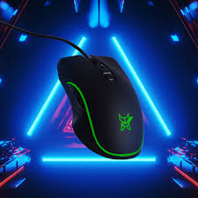

  A mouse is a pointing device that allows users to interact with graphical user interfaces (GUIs) by moving a cursor on the screen. It consists of a small ball that detects the movement of the user's hand and sends signals to the computer to determine the position of the cursor

**3.Joystick**

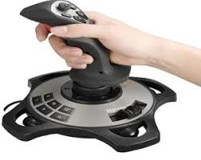

A joystick is an input device that consists of a stick with a button or buttons attached to it. It is used to control a character or object in a computer game or to navigate through menus in a game or application. Joysticks are commonly used in video games, flight simulators, and other interactive applications

Section 4: Practical Application

11. Identify and label the following components on a diagram of a

motherboard:

● CPU

● RAM slots

● SATA connector

● PCI-E slot

**SATA SLOT** **PCI slot**

**RAM**

## Motherboard | Definition, History, & Facts | Britannica

**CPU**

12. Demonstrate how to install a RAM module into a computer.

Ans.

1. Identify Ram Slot
2. Open Lock
3. Match Notch
4. Insert Ram

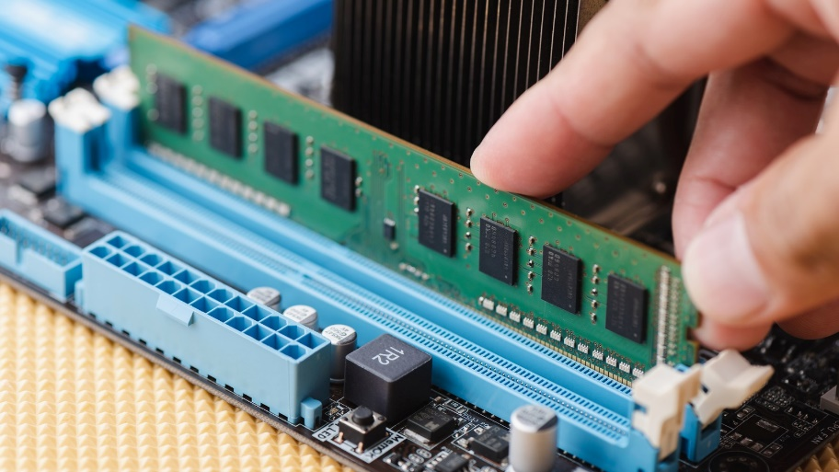

Section 5: Essay

13. Discuss the importance of proper cooling mechanisms in a computer.

Ans.

Proper cooling mechanisms are crucial for maintaining the optimal performance and stability of a computer. They help to keep the components of the system cool, preventing overheating and potential damage to the hardware.

Overheating components can lead to reduced performance, increased noise levels, and potential damage to the hardware. Cooling helps to maintain the temperature of the components within acceptable limits.

Cooling helps to reduce the amount of energy required to maintain the system at a given temperature, which can be beneficial for power-constrained environments.

Overheating can cause components to fail prematurely, leading to data loss, system crashes, or other issues. Proper cooling helps to extend the life of the computer and its components.

14. Explain the concept of bus width and its significance in computer Architecture.

**Cache**

**CPU**

Front side bus

Backside bus

**Onboard LAN**

**USB Serial**

**Onbound Audio**

**Floppy Controller**

**South Bridge**

**Memory Controller**

**North Bridge**

**PCI Controller**

computer architecture, the bus width determines the size of the data packets that can be processed by the CPU, memory, and other components. A higher bus width allows for faster data transfer and more efficient processing of large amounts of data. However, higher bus width also increases the complexity of the system and requires more hardware resources.

Thank You.